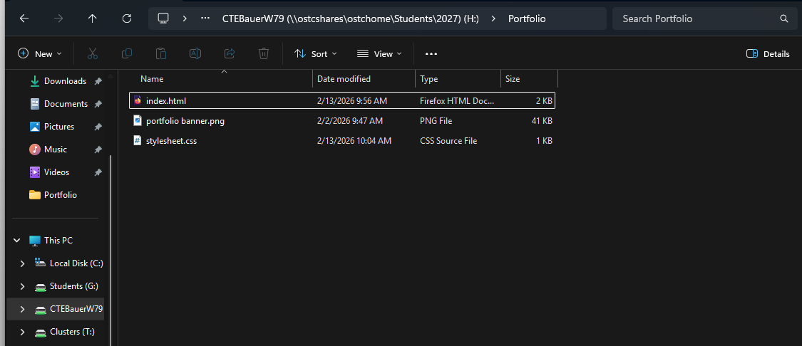
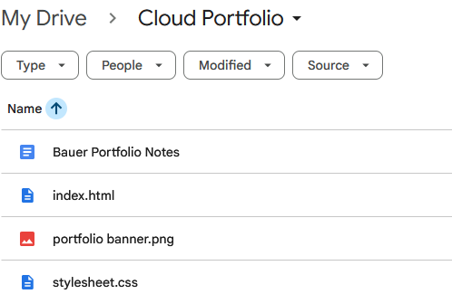
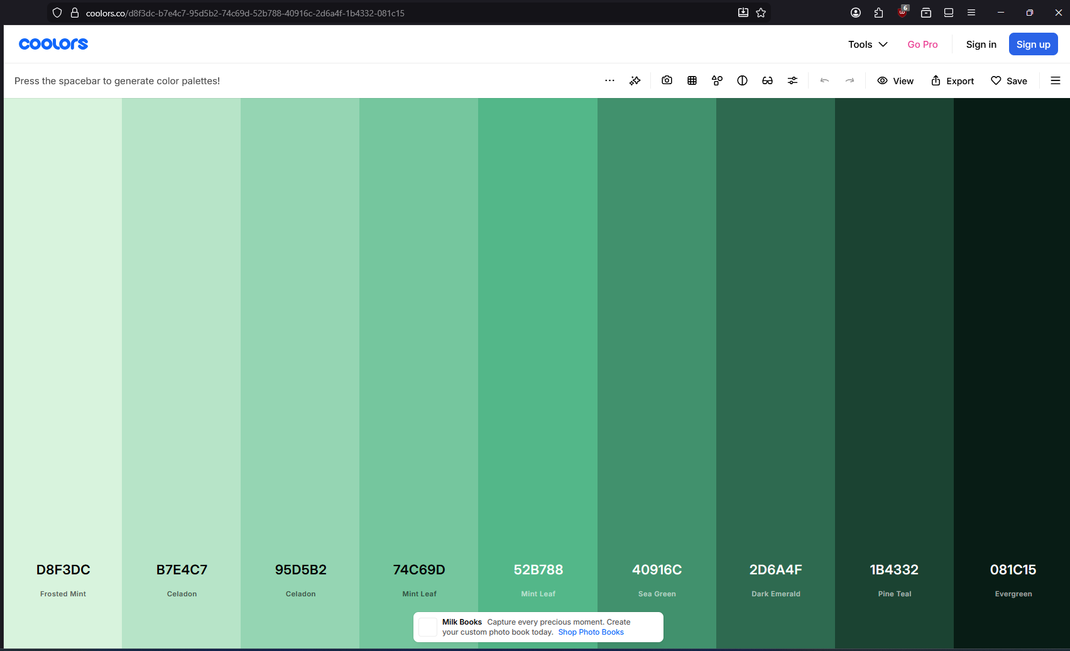https://coolors.co/d8f3dc-b7e4c7-95d5b2-74c69d-52b788-40916c-2d6a4f-1b4332-081c15
d8f3dc 216, 243, 220
b7e4c7 183, 228, 199
95d5b2 149, 213, 178
74c69d 116, 198, 157
52b788 82, 183, 136
40916c 64, 145, 108
2d6a4f 45, 106, 79
1b4332 27, 67, 50
081c15 8, 28, 21

